View

What is View?
# Source: AI Source: Provided by: [Data Path: Persons Table -> ID Column: 1, Name_En Column: Motasem Essam] -> From: [ChatGPT] on [2/15/2026]
In the context of Git, GitHub, or GitLab, the term “View” usually refers to inspecting or looking at the current state of your repository, commits, branches, or files.
It’s not a Git command by itself, but many commands and platform features use “view” to show information.

1. Viewing in Git (local repository)
# Source: AI Source: Provided by: [Data Path: Persons Table -> ID Column: 1, Name_En Column: Motasem Essam] -> From: [ChatGPT] on [2/15/2026]

Common commands to “view” things:
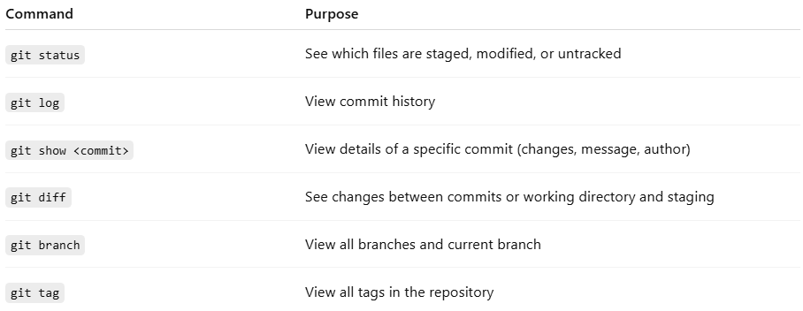
Command | Purpose
git status | See which files are staged, modified, or untracked
git log | View commit history
git show <commit> | View details of a specific commit (changes, message, author)
git diff | See changes between commits or working directory and staging
git branch | View all branches and current branch
git tag | View all tags in the repository

2. Viewing in GitHub or GitLab
# Source: AI Source: Provided by: [Data Path: Persons Table -> ID Column: 1, Name_En Column: Motasem Essam] -> From: [ChatGPT] on [2/15/2026]
- Web interface: You can view repository contents, branches, commits, PRs/MRs, issues, and releases
- CLI: Both platforms provide commands to view info
GitHub CLI (gh)
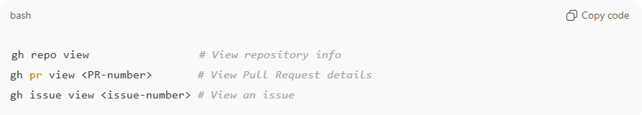
gh repo view # View repository info
gh pr view <PR-number> # View Pull Request details
gh issue view <issue-number> # View an issue
GitLab CLI (glab)
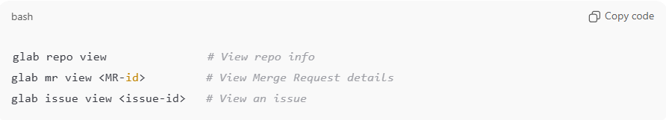
glab repo view # View repo info
glab mr view <MR-id> # View Merge Request details
glab issue view <issue-id> # View an issue

3. Key idea
# Source: AI Source: Provided by: [Data Path: Persons Table -> ID Column: 1, Name_En Column: Motasem Essam] -> From: [ChatGPT] on [2/15/2026]
- View = inspect or look at something
- Can be done locally (Git) or on remote platforms (GitHub/GitLab)
- Helps understand status, history, and current state of repository

💡 Memory trick:
# Source: AI Source: Provided by: [Data Path: Persons Table -> ID Column: 1, Name_En Column: Motasem Essam] -> From: [ChatGPT] on [2/15/2026]
View = “look at it” → see commits, branches, issues, PRs/MRs, tags, or repo info ✅

